

Project Report

CSE 331L

Microprocessor Interfacing & Embedded Systems

Section 07

Summer 2020

North South University

Submitted to: Rishad Arfin (RSF)

Submission Date: September 30th,2020

Group Members:

|  |  |  |
| --- | --- | --- |
| **Name** | **NSU ID** | **NSU Email Address** |
| Jahin Mahbub | 1531552042 | JAHIN.MAHBUB@NORTHSOUTH.EDU |
| Tarana Kabir | 1620404042 | TARANA.KABIR@NORTHSOUTH.EDU |
| Sakiba Sabrina | 1631165042 | SAKIBA.SABRINA@NORTHSOUTH.EDU |
| Asaduzzaman Noor | 1631231042 | ASADUZZAMAN.NOOR@NORTHSOUTH.EDU |

**Guided Project**

**Electronic voting machine using 8051/PIC microcontroller**

**Introduction:**

The purpose of this project is to digitalize our ancient voting system. The reason behind doing this project is to get to know how embedded system works, responds to different signals. This project is interesting because it solves the problem that our ancient voting system has, counting the vote. It automatically sums up the votes and upon request it show the status of the candidates instantly.

**Components Used:**

1. 8051/PIC Microcontroller.
2. 6 buttons.
3. 1 LCD interfacing Module.

**Applications:**

In our EVM the standard features include:

* User friendly operation sequence.
* A clash Between feature is there if a deadlock of votes arises.
* Portable and easy to operate.
* Reliable, robust and error free machine.
* Legacy software with machine codes used to preserve integrity and security.
* Preserves voting secrecy.
* No scope for invalid votes.
* Facilitates quick and accurate counting – possible to declare results instantaneously.
* Simple to operate and can be installed in a short time.
* Modernizes the election process.

**Working Procedures:**

The working Procedures step-by-step are given below,

1. In our Project, the first step we took was to write the C code of project. Planning out what features there would be and Figuring out the logic of those features and how we can implement them The C code was written using CodeBlocks.
2. The Second step was to put our Finished C code (The .c file) into mikroC PRO. But in our case we used MicroVision instead. It yielded the same result as it generated the required .HEX file.
3. Once the HEX file was generated, we started to work on our Schematic Circuit on Proteus. We figured out we needed 6 Buttons, An LCD Interface and of course, a MicroController PIC/8051. We connected the components together and included the HEX file in the Microcontroller Schematic.
4. Once that Schematic was fully configured and ready to run, we tested our features. Below are the Schematic Diagrams showing the Different features.

**Images of our Schematic Circuit in action:**

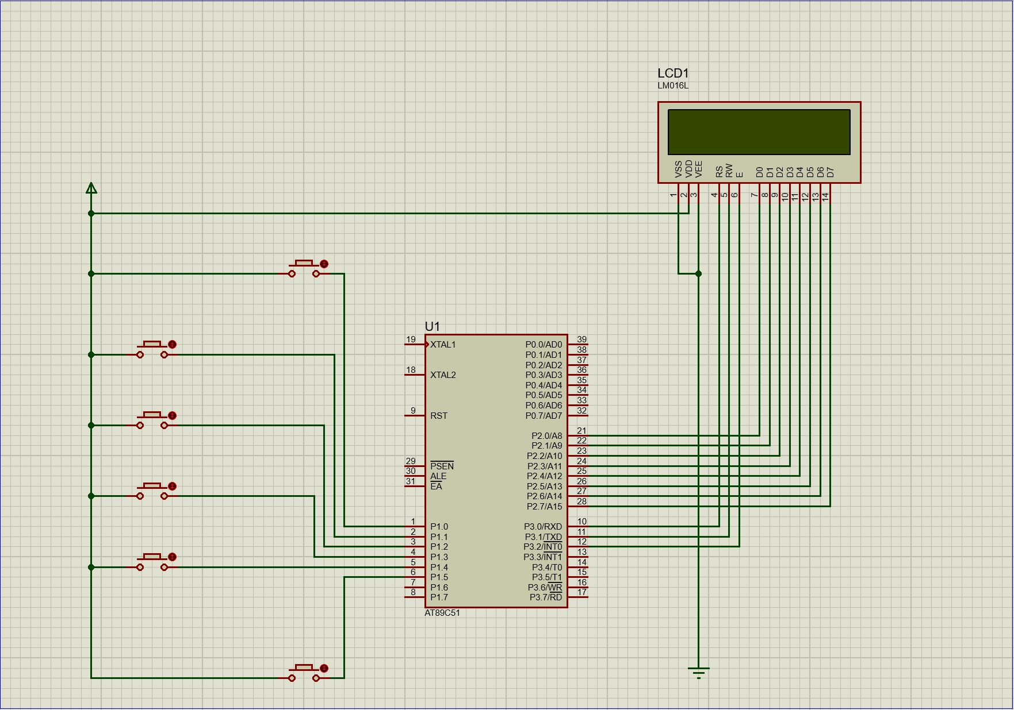

***Figure:*** *Initial Stage of the circuit.*

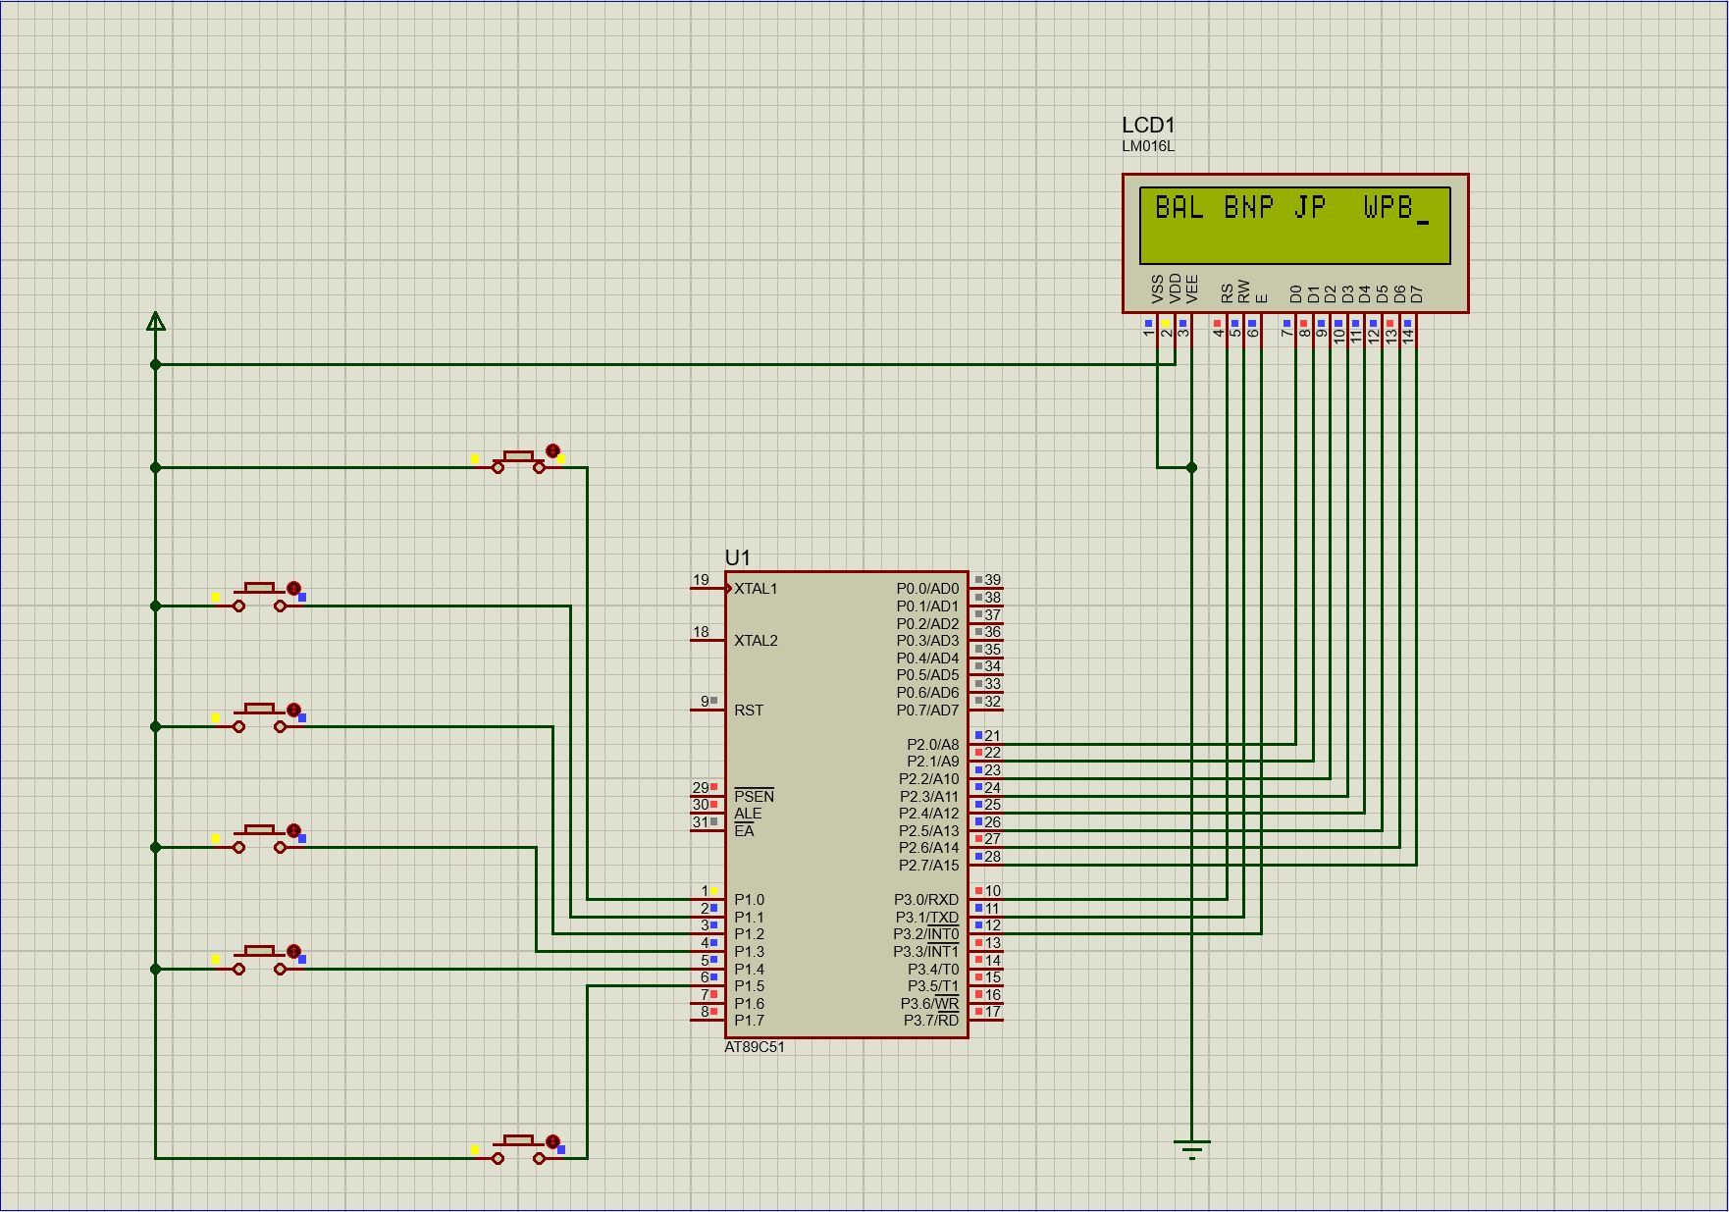

***Figure:*** *Voting Started.*

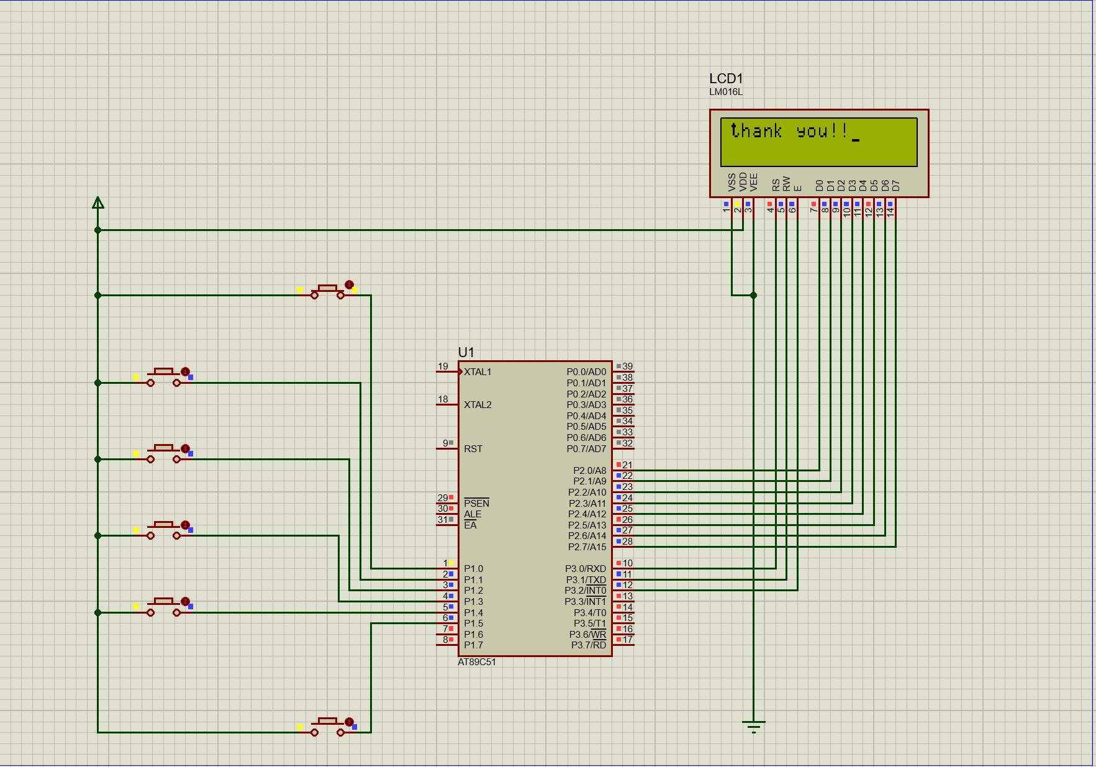

***Figure:*** *Your vote has been cast.*

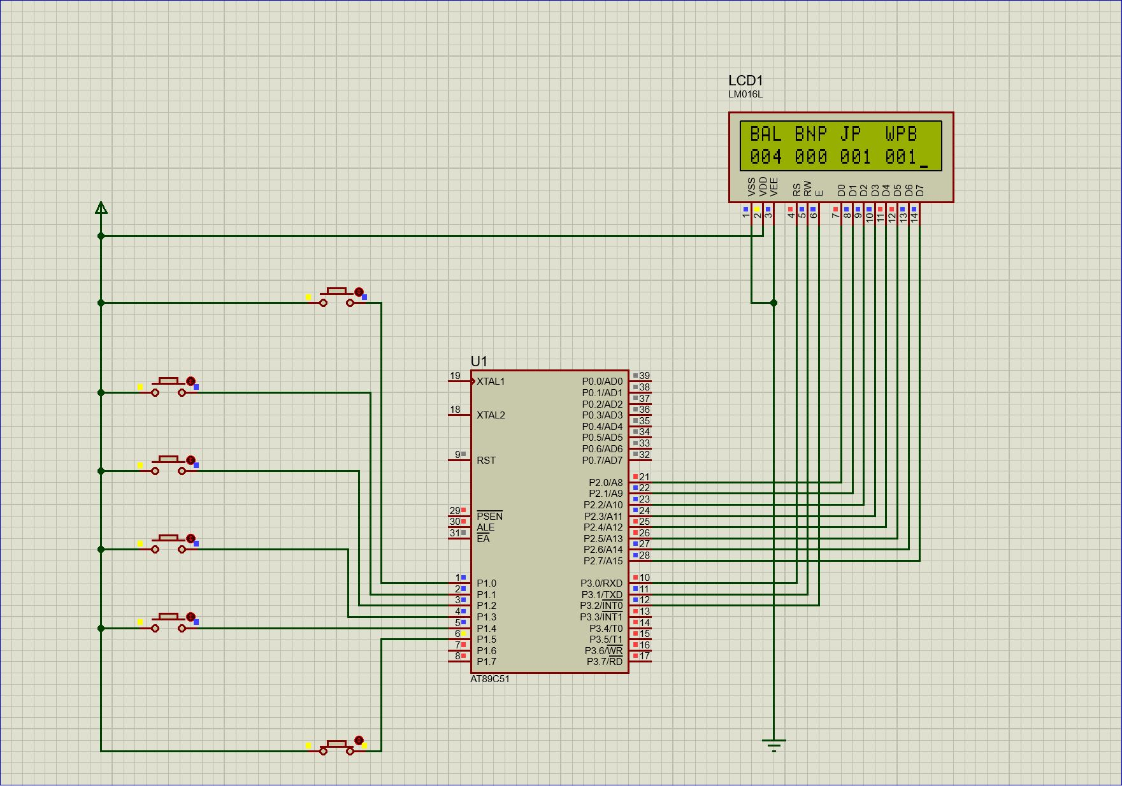

***Figure:*** *Results determined.*

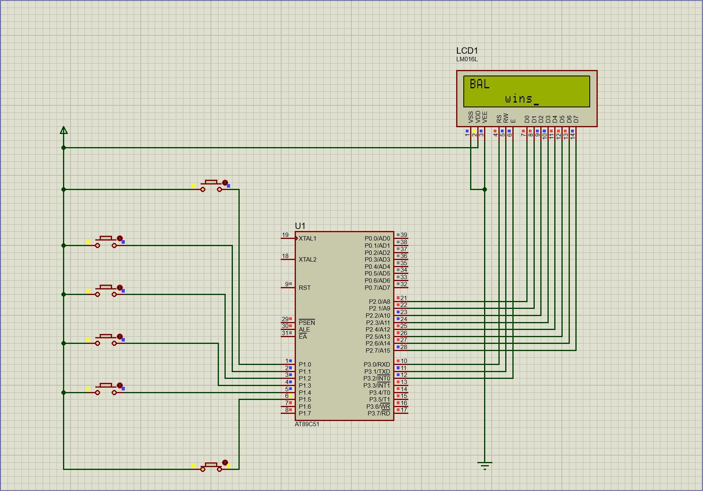

***Figure:*** *Results Announced.*

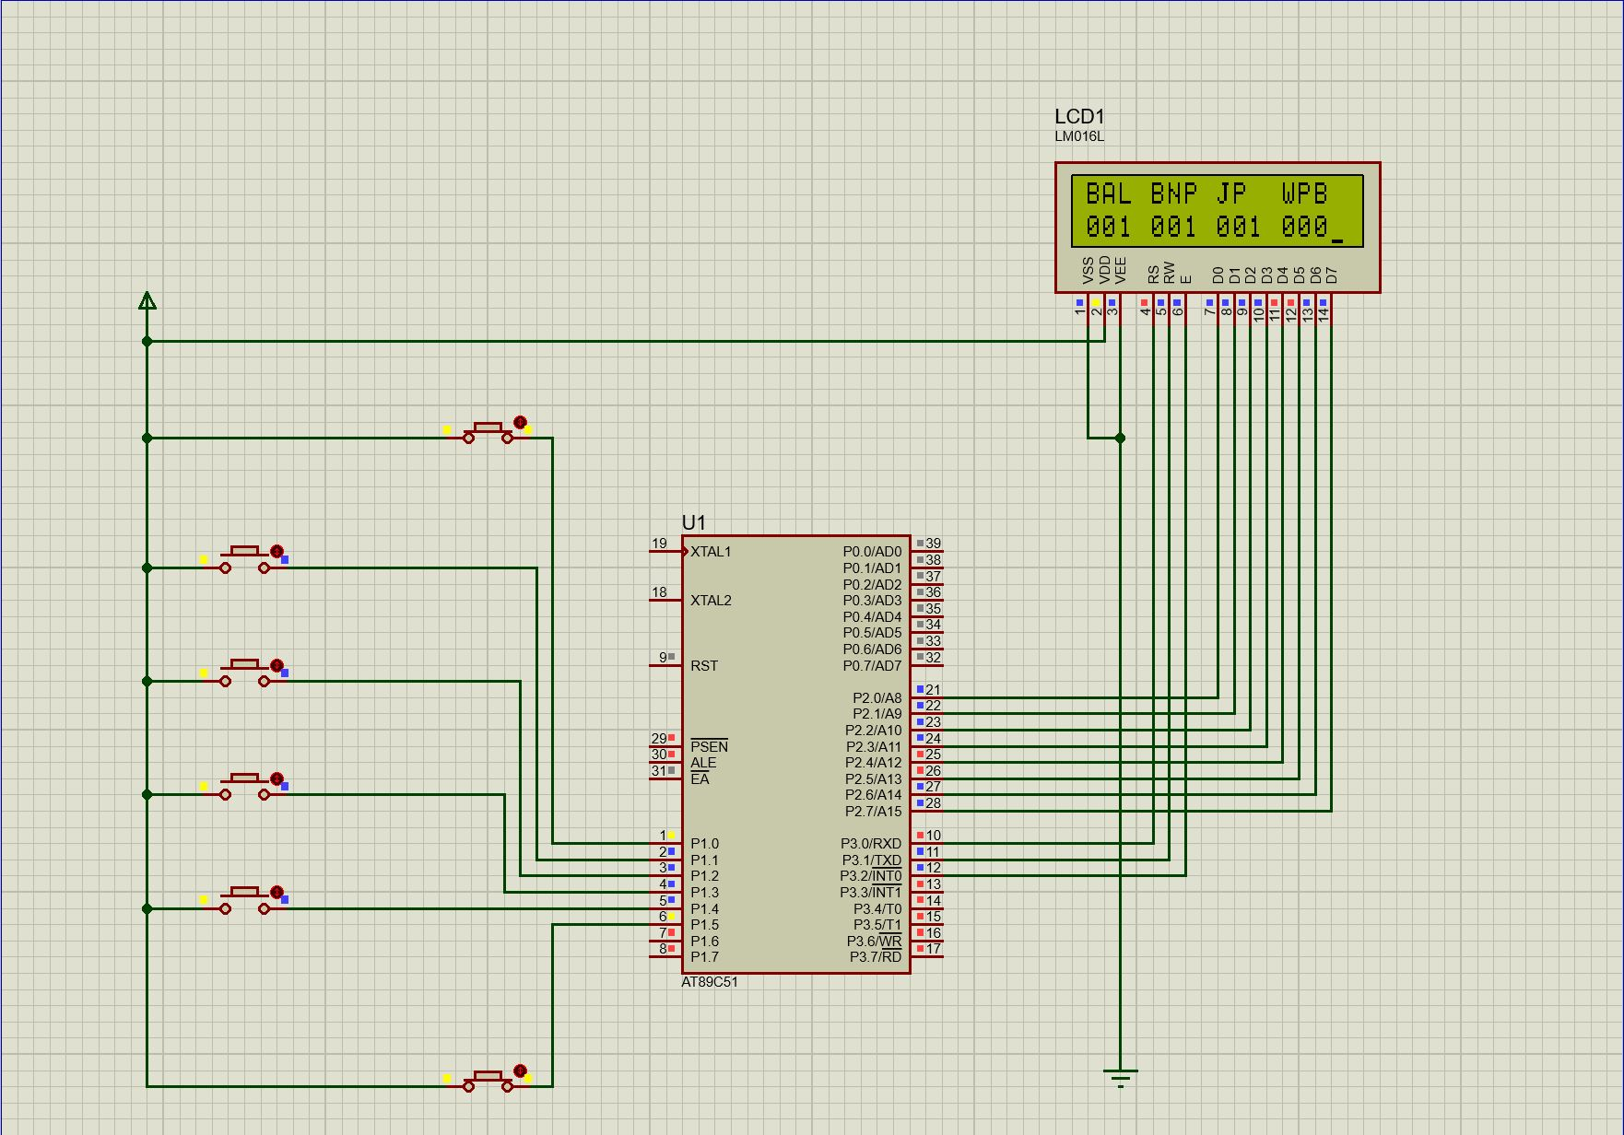

***Figure:*** *A Clash was found.*

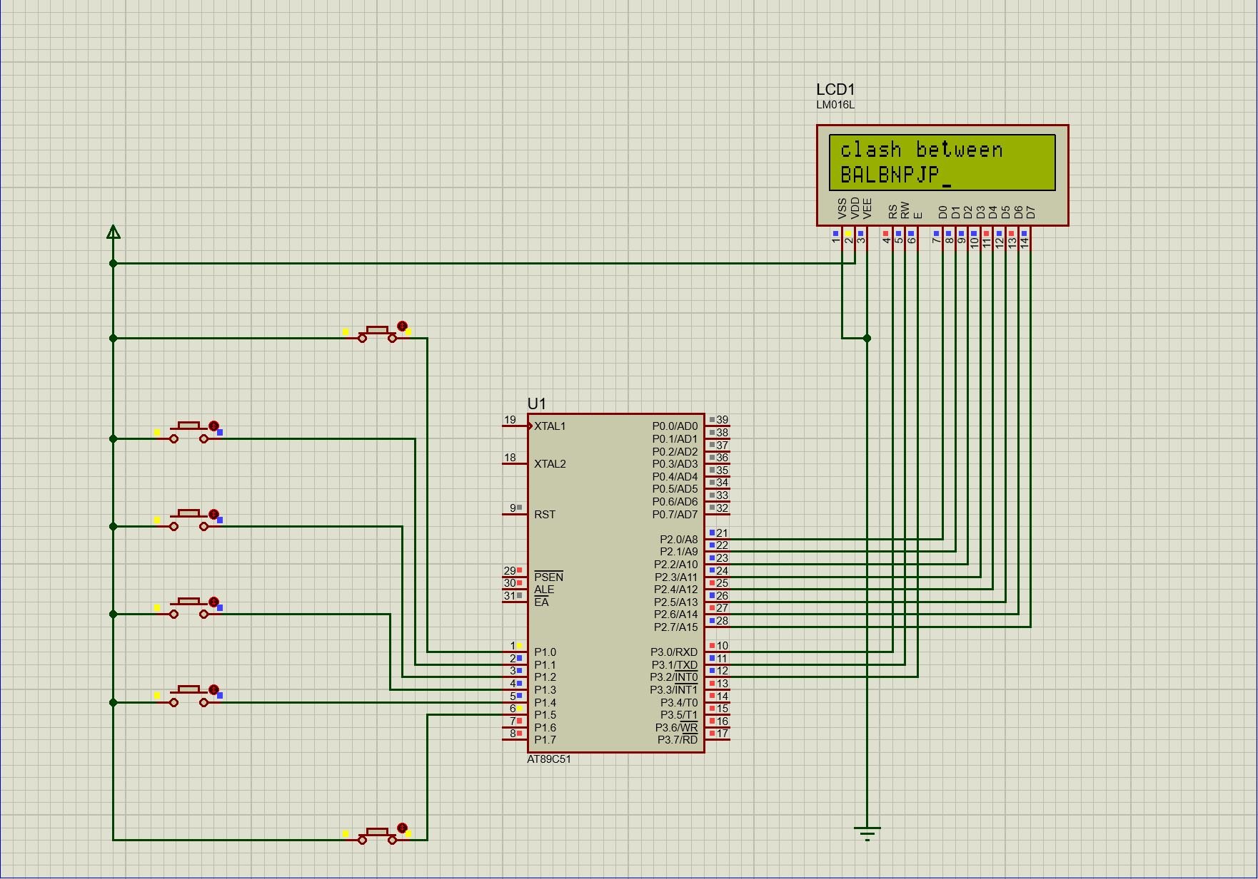

***Figure:*** *Clash Announced.*

**Code Segment:**

#include <reg51.h>

#define lcdport P2

sbit rs=P3^0;

sbit rw=P3^1;

sbit en=P3^2;

sbit start= P1^0;

sbit stop= P1^5;

sbit party1=P1^1; //Candidate1

sbit party2=P1^2; //Candidate2

sbit party3=P1^3; //Candidate3

sbit party4=P1^4; //Candidate4

void lcdcmd(char);

void lcdint();

void lcddata(char);

void lcdstring(char*);

void delay(unsigned int);

void longdelay(unsigned int);

void dispaly_vote(unsigned int);

void count();

void result();

void check();

unsigned int vote1,vote2,vote3,vote4 ;

char vote_no[4];

void main() {

lcdport = 0x00;

party1 = party2 = party3 = party4 = 0;

vote1 = vote2 = vote3 = vote4 = 0;

start = stop = 0;

lcdint();

lcdstring("press start ");

lcdcmd(0xc0);

lcdstring("to initiate");

while(1) {

if(start == 1) {

lcdcmd(0x84);

lcdcmd(0x01);

lcdstring("WELCOME!!");

longdelay(200);

lcdcmd(0x01);

lcdstring("press any key");

lcdcmd(0xc0);

lcdstring("to vote");

longdelay(200);

lcdcmd(0x01);

lcdstring("BAL");

delay(500);

lcdcmd(0x84);

lcdstring("BNP");

delay(500);

lcdcmd(0x88);

lcdstring("JP");

delay(500);

lcdcmd(0x8C);

lcdstring("WPB");

count();

lcdcmd(0x01);

lcdcmd(0x80);

lcdstring("thank you!!");

longdelay(500);

check();

}

}

}

void check() {

if(party1 == 0 && party2 == 0 && party3 == 0 && party4 == 0) {

if(stop != 0) {

while(1)

result();

}

}

}

void result() {

int max = 0, flag = 0;

lcdcmd(0x01);

lcdstring("BAL");

delay(500);

lcdcmd(0x84);

lcdstring("BNP");

delay(500);

lcdcmd(0x88);

lcdstring("JP");

delay(500);

lcdcmd(0x8C);

lcdstring("WPB");

lcdcmd(0xc0);

dispaly_vote(vote1);

lcdcmd(0xc4);

dispaly_vote(vote2);

lcdcmd(0xc8);

dispaly_vote(vote3);

lcdcmd(0xcc);

dispaly_vote(vote4);

if(vote1 > max)

max = vote1;

if(vote2 > max)

max = vote2;

if(vote3 > max)

max = vote3;

if(vote4 > max)

max=vote4;

longdelay(500);

if ( (vote1 == max) && ( vote2 != max) && (vote3 != max) && (vote4 != max) ) {

flag = 1;

lcdcmd(0x01);

lcdcmd(0x80);

lcdstring("BAL");

lcdcmd(0xc5);

lcdstring("wins");

longdelay(500);

}

if ( (vote2 == max) && ( vote1 != max) && (vote3 != max) && (vote4 != max) ) {

flag = 1;

lcdcmd(0x01);

lcdcmd(0x80);

lcdstring("BNP");

lcdcmd(0xc5);

lcdstring("wins");

longdelay(500);

}

if ( (vote3 == max) && ( vote2 != max) && (vote1 != max) && (vote4 != max) ) {

flag = 1;

lcdcmd(0x01);

lcdcmd(0x80);

lcdstring("JP");

lcdcmd(0xc5);

lcdstring("wins");

longdelay(500);

}

if ( (vote4 == max) && ( vote2 != max) && (vote1 != max) && (vote3 != max) ) {

flag = 1;

lcdcmd(0x01);

lcdcmd(0x80);

lcdstring("WPB");

lcdcmd(0xc5);

lcdstring("wins");

longdelay(500);

}

if(flag == 0) {

lcdcmd(0x01);

lcdcmd(0x80);

lcdstring("clash between");

lcdcmd(0xc0);

if(vote1 == max)

lcdstring("BAL");

if(vote2 == max)

lcdstring("BNP");

if(vote3 == max)

lcdstring("JP");

if(vote4 == max)

lcdstring("WPB");

longdelay(200);

}

}

void dispaly_vote(unsigned int vote) {

int k, p;

for (k = 0; k <= 2; k++) {

vote_no[k] = vote % 10;

vote = vote / 10;

}

for (p = 2; p >= 0; p--)

lcddata(vote_no[p]+48);

}

void count() {

while(party1 == 0 && party2 == 0 && party3 == 0 && party4 == 0);

if (party1 == 1)

vote1 = vote1 + 1;

if (party2 == 1)

vote2 = vote2 + 1;

if (party3 == 1)

vote3 = vote3 + 1;

if (party4 == 1)

vote4 = vote4 + 1;

}

void delay(unsigned int x) {

unsigned int i;

for(i=0; i<x; i++);

}

void longdelay(unsigned int u) {

unsigned int i,j;

for(i=0; i<u; i++)

for(j=0; j<1275; j++);

}

void lcdint() {

lcdcmd(0x38);

delay(500);

lcdcmd(0x01);

delay(500);

lcdcmd(0x0c);

delay(500);

lcdcmd(0x80);

delay(500);

lcdcmd(0x0e);

delay(500);

}

void lcdcmd(char value) {

lcdport = value;

rw=0;

rs=0;

en=1;

delay(500);

en=0;

}

void lcdstring(char *p) {

while(*p != '\0') {

lcddata(*p);

delay(2000);

p++;

}

}

void lcddata(char value) {

lcdport = value;

rs=1;

rw=0;

en=1;

delay(500);

en=0;

}

**Discussion:**

The results of the project are as follows:

* The machine casted the votes properly.
* The machine reported that your vote was received and counted.
* The machine can determine and show the result instantaneously as promised.
* The machine can determine if there is a deadlock in the votes i.e. Two or more parties have the same number of votes.
* The Machine can report a Deadlock through showing us the results.

Discussing the results, we believe throughout the process of our project we have ensured that we would make a working Electronic Voting Machine. And we did. The Logic behind the code was difficult to figure out but through back and forth from Micro vision and Proteus we can ensure that it functions perfectly. The Schematic Diagram we can confirm was made without any defect. Even though we must admit the configuration of the buttons could have been simpler. We have more than delivered our promise from what we outlined on the proposal our features would be. In that we have added more functions later on.

**Working Contributions:**

|  |  |
| --- | --- |
| **Name** | **Contributions** |
| Jahin Mahbub | Project Report Writing, Code. |
| Tarana Kabir | Project Proposal Writing, Schematic Diagram. |
| Sakiba Sabrina | Code, Schematic Diagram. |
| Asaduzzaman Noor | Code, Schematic Diagram, HEX file Generation. |